How to connect the control node and manage node :
I tried to install the ansible by directly through but it through me an error
Sudo install ansible -y
Instead of that I tried it to download it through the pip of python :
- sudo dnf install python3-pip -y
- pip3 install --user ansible
- ansible –version(to see wheather the ansible had been installed or not)

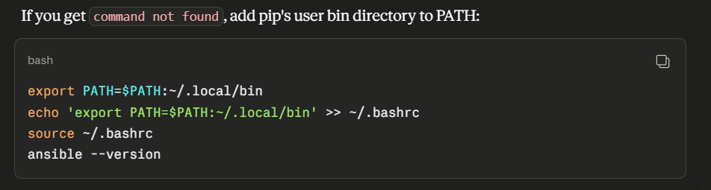

Then we need to generate an ssh key pair on the control node :
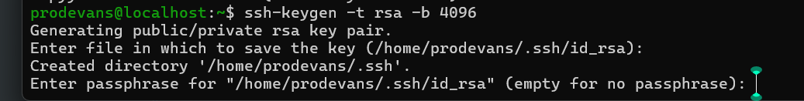
Why we should use the key phrase :
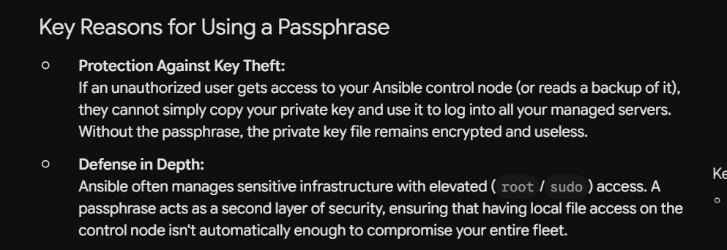

Then it will create an location of the file where the private key is stored :
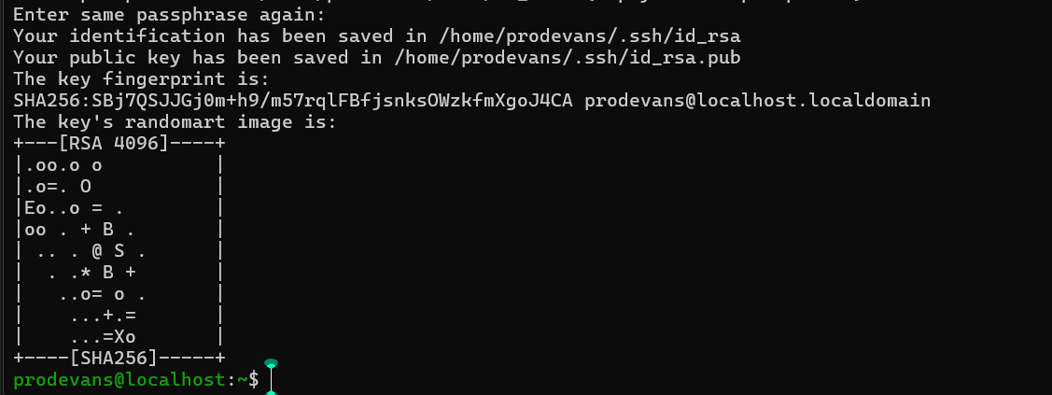
Then once the private and public key is generated then we need to do on control node and the manage nodes:
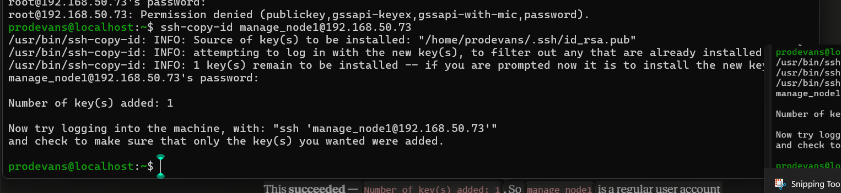
To cross verify wheather it worked or not on the control node type the manage node ssh:
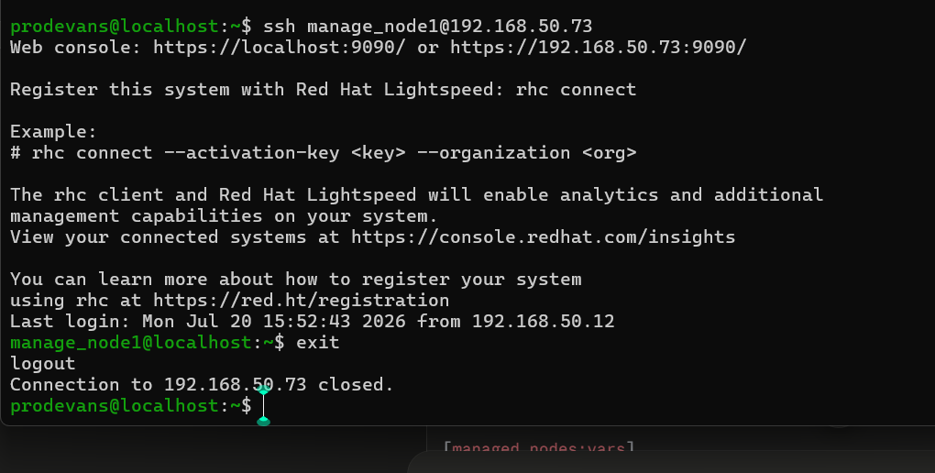
Then check wheather on the both managed nodes wheather the python is installed or not by using the
“python –version”

Then we are creating an folder on the control node :
The inventory file tells to the ansible which machine exists and how to connect to them:
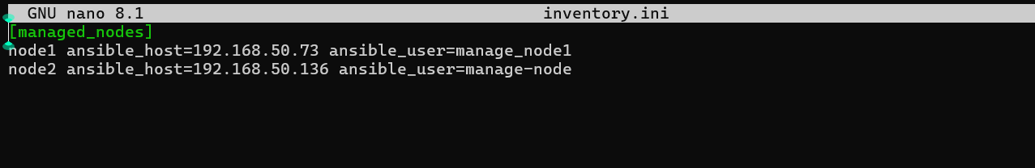
Create an ansible.conf file:
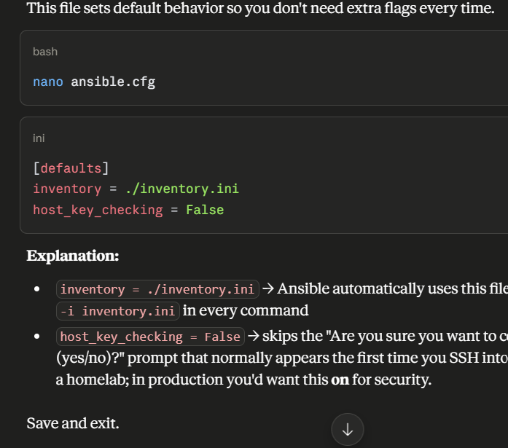
Once all the steps are done ,then cross verify this from your control node: 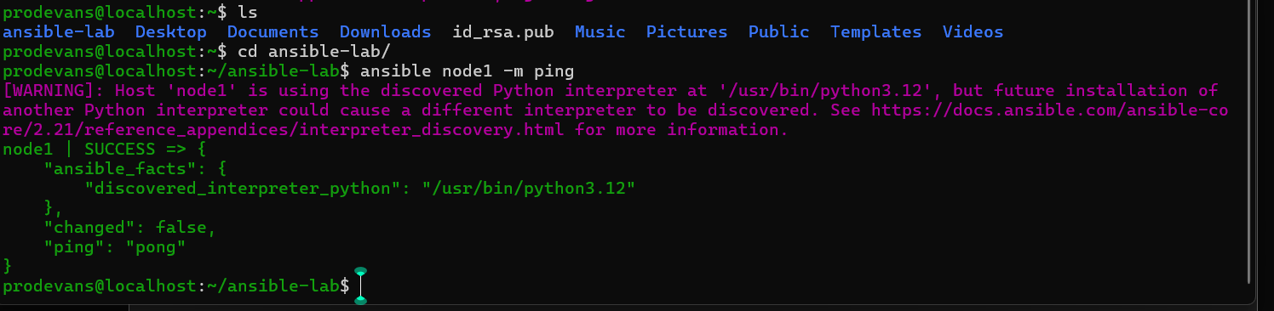

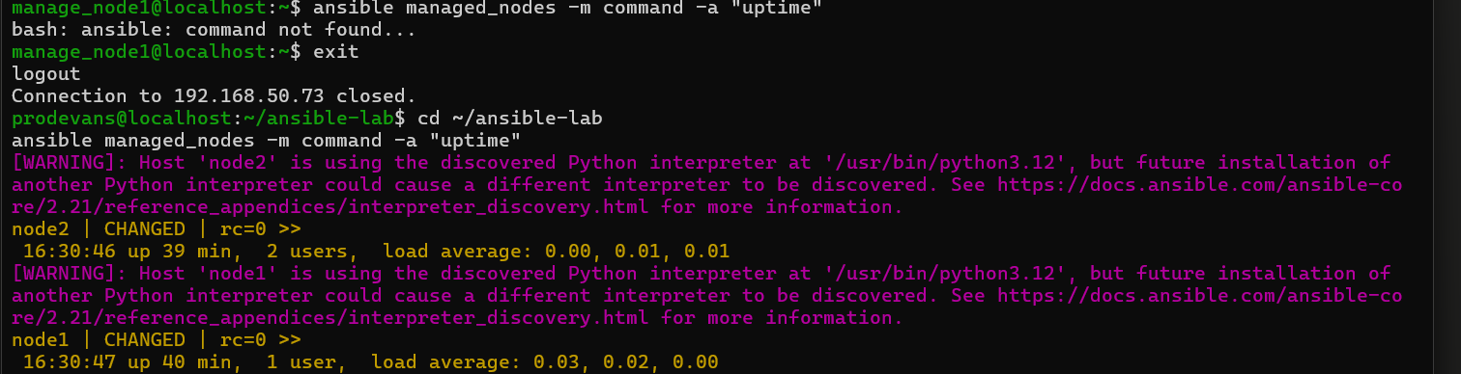
Run a real command on both managed nodes (proves shell execution works, not just the ping module):

Real world use case:
Great question — understanding the "why" behind this makes everything you just did click into place. Let's connect it to real-world scenarios.
The Core Problem Ansible Solves
Imagine you're a sysadmin/DevOps engineer managing not 2, but 200 servers. Without Ansible, if you needed to install a security patch on all of them, you'd have to:
ssh server1
sudo dnf update -y
exit
ssh server2
sudo dnf update -y
exit
... (repeat 198 more times)
This is slow, error-prone, and impossible to track. Ansible lets you run one command from your control node that does this across all 200 servers simultaneously:
ansible all -m dnf -a "name=* state=latest"
The SSH connectivity you just set up is the foundation that makes this possible — it's literally the pipe through which every future automation task flows.

Real-World Use Case 1: Patch Management / Updates
Scenario: Your company has 50 web servers. A critical CVE (security vulnerability) drops today and needs patching across all of them before end of day.
ansible webservers -m dnf -a "name=openssl state=latest" --become
One command, 50 servers patched, with a report showing exactly which succeeded/failed. This is the exact ping connectivity test you just did — scaled up.

Real-World Use Case 2: Configuration Consistency (Config Drift Prevention)
Scenario: You have web servers that are all supposed to have identical Nginx configs, but over months of manual SSH tweaks, they've drifted apart — one has a different timeout setting, another has an extra config file someone forgot to remove.
With Ansible, you write a playbook (a YAML file describing desired state) once:
- name: Ensure nginx config is standardized
hosts: webservers
tasks:
- name: Copy standard nginx.conf
copy:
src: nginx.conf
dest: /etc/nginx/nginx.conf
notify: restart nginx
Run it against all servers — every single one is forced back into the exact same state. This is huge in real companies because "works on my server but not that one" bugs are extremely common and costly to debug.

Real-World Use Case 3: New Server Provisioning (Onboarding)
Scenario: Your company spins up a new VM every time a developer needs a test environment, or when scaling up for traffic. Instead of manually installing Docker, configuring users, setting firewall rules, and hardening SSH by hand each time (30+ minutes of repetitive work), you write it once as a playbook:
- name: Bootstrap new server
hosts: new_servers
tasks:
- name: Install Docker
dnf: name=docker state=present
- name: Create deploy user
user: name=deploy groups=docker
- name: Configure firewall
firewalld: service=https permanent=true state=enabled
This turns a 30-minute manual process into a 2-minute automated one — and it's identical every time, eliminating human error.

Real-World Use Case 4: Your Specific Homelab (Foreman/Katello context)
Since you're building out Foreman/Katello and RHEL VMs, here's how this directly applies to what you're doing:
- Foreman/Katello manages content (RPM repos, patches, subscriptions) — but Ansible is what actually applies configuration to hosts.
- In real enterprise RHEL environments, Foreman + Ansible work together: Foreman handles provisioning and patch content, Ansible (often via Ansible Automation Platform / AWX, Red Hat's product) handles configuration management — deploying users, applying security baselines (like CIS benchmarks), configuring DNS clients to point at your BIND server, etc.
For example, you could write a playbook that goes to every managed node and:
- name: Point all clients to homelab DNS
hosts: managed_nodes
tasks:
- name: Set DNS server
lineinfile:
path: /etc/resolv.conf
line: "nameserver 192.168.50.1"
Instead of manually editing /etc/resolv.conf on every VM you spin up, you push it out to all managed nodes in one shot.

Real-World Use Case 5: Compliance and Auditing
Scenario: Your company needs to prove to auditors that every server has disk encryption enabled, a specific password policy, and no unauthorized users. Instead of manually checking 100+ servers:
ansible all -m shell -a "cat /etc/login.defs | grep PASS_MAX_DAYS"
You get a consolidated report across your entire fleet in seconds — critical in industries like finance, healthcare, and government where compliance audits are frequent and expensive if failed.

Real-World Use Case 6: Zero-Downtime Application Deployment
Scenario: You're deploying a new version of a web app across a cluster of servers behind a load balancer. You don't want to take all servers down at once (that would cause an outage).
Ansible can do rolling updates:
- hosts: webservers
serial: 2 # updates 2 servers at a time, not all at once
tasks:
- name: Pull latest app version
git: repo=https://github.com/company/app.git dest=/var/www/app
- name: Restart app service
systemd: name=myapp state=restarted
This is exactly how companies like Netflix, Airbnb, and thousands of others deploy code without users ever noticing downtime.

Why the SSH Key Setup Specifically Matters at Scale
In a real company, you're not manually running ssh-copy-id for 200 servers. Instead:
- New servers get provisioned with your control node's public key pre-installed (via a "golden image" or PXE/kickstart automation — which ties back to your Foreman work)
- Or centralized identity management (like FreeIPA/IdM, or even Active Directory integration) handles authentication instead of individual key files
- Ansible Automation Platform (AWX/Tower) centralizes credential management so individual engineers don't even see the private key — it's stored securely and injected at runtime
What you did manually (generate key → copy to each host → verify) is the conceptual foundation every automated onboarding process is built on top of.

Summing It Up
What you did | Real-world equivalent
SSH key setup | How control planes authenticate to hundreds/thousands of servers securely, without passwords
Inventory file | A living map of your entire infrastructure — which servers exist, grouped by role (web, db, DNS, etc.)
ansible -m ping | The first health check any automation pipeline runs before deploying anything — "can I even reach this fleet?"
Ad-hoc commands (uptime, command) | Quick fleet-wide diagnostics during incidents (e.g., "is everything up? what's the load average across all servers right now?")
The 2-node setup you built is literally the exact same architecture used to manage fleets of thousands of servers at companies like Red Hat, Meta, and any enterprise using Infrastructure as Code — just at a smaller scale for learning. Once you're comfortable with ad-hoc commands, the natural next step is playbooks, which is where this really starts to shine for tasks like the config-drift and deployment examples above. Want me to walk through building your first real playbook next — maybe something practical like configuring both managed nodes to use your BIND DNS server?

